Answer Sheet / Using Excel Pivot Tables for Analytics

|  |  |
| --- | --- |
| STUDENT NAME | **Rakshit Bhardwaj** |

|  |  |
| --- | --- |
| Camera | **Provide screenshots to support your answers.** |

1. What was the overall revenue? Which year had the highest revenue and what was the revenue during that year?

Overall Revenue**: $28,52,50,872.77**

Highest Revenue Year: **2007**

Revenue in 2007: **$6,07,15,831.69**

1. What is the Revenue for E-Bike in 2010?

Revenue for E-Bike in 2010: **$20,24,435.69**

1. What is the Revenue for E-Bike in 2009?

Revenue for E-Bike in 2009: **NIL**

1. What is the Sales Quantity of T-shirts for Airport Bikes in 2007?

Sales Quantity of T-shirts for Airport Bikes in 2007: **$30**

1. What year had the highest Sales Quantity?

Highest Sales Quantity Year: **2007**

1. What year had the lowest Revenue?

Lowest Revenue Year: **2009**

1. In the year with the lowest Revenue, which Material had the lowest revenue?

In the Lowest Year of Revenue, The Material with the Lowest Revenue**: Fixed Gear Bike Plus**

1. Which material had the lowest revenue overall?

Material with Lowest Revenue Overall: **Water Bottle**

1. In the year that had the highest Net Sales, what division had the highest Net Sales?

Year (2007) that had Highest Net Sales, the Division that had Highest Net Sales: **BI**

1. For the division in Question 9, which customer had the highest Net Sales?

**Customer: 15000**

1. In the year with the lowest Revenue, what division had the highest sales revenue?

Year (2009) with the Lowest Revenue, Division with Highest Sales Revenue: **BI**

1. For the division in Question 11, which customer had the highest Net Sales for all years?

**Customer 15000**

1. What customer provided the highest revenue for Accessories (Division AS) in 2009?

**Customer 15000**

1. In 2011, for Bicycles (Division is BI), what is the total revenue for the top three customers

Total revenue for the top three customers: **$1,48,74,934**

1. What is the average Revenue per customer?

Average Revenue per customer: **$9,773**

1. What is the average revenue per customer per year? Which year has the highest average revenue per customer? How much is that amount?

Average revenue per customer in 2007: **$9,970**

Average revenue per customer in 2008: **$10,036**

Average revenue per customer in 2009: **$9,282**

Average revenue per customer in 2010: **$9,648**

Average revenue per customer in 2011: **$9,903**

Year with Highest average revenue per customer: **2008**

Amount**: $10,036**

1. What is the average revenue per customer per year per division?

Average revenue per customer per division AS: **$209**

Average revenue per customer per division BI**: $15,717**

1. Which customer has the highest average Revenue during the year?

The Customer with the highest average revenue during the year: **Bavaria Bikes**

1. Are the historical (year by year) Revenue trends for the US and Germany (DE) similar or dissimilar?

**Dissimilar**

1. Did GBI ever gain or lose a customer (based on revenue)? Explain

**Cannot Estimate Loss/Gain of Customer with this chart**. On an average the trend line averages out for all the years (except for Silicon Valley 2011 with a Null Value). More metrics is involved when estimating gain or loss of customers. In this case Customer could be a Confounding variable for Changes in Revenue and Price changes could be a factor for Revenue calculation.

1. Is there seasonality in revenue during the year? If so, what month has the highest revenue? Is the seasonality similar from year to year?

**Yes**, there is a seasonality in revenue during the year.

**June** has the highest revenue.

**Yes,** seasonality is **similar** from year to year.

1. Which material does not display significant seasonality?

**First Aid Kit**

1. What customer has the highest percentage contribution to revenue? What has been the trend of that customer’s percentage contribution over the years?

**Bavaria Bikes** has the highest percentage contribution to revenue.

The trend of the Bavaria Bikes Percentage contribution since 2007 has been gradually, marginally on the **Positive** side (increment) and averages to around **20%** over the years.

1. What year had the highest overall gross margin? What was the gross margin during that year?

The Year with the highest overall gross margin: **2007**

Gross Margin for 2007: **$2,88,91,764**

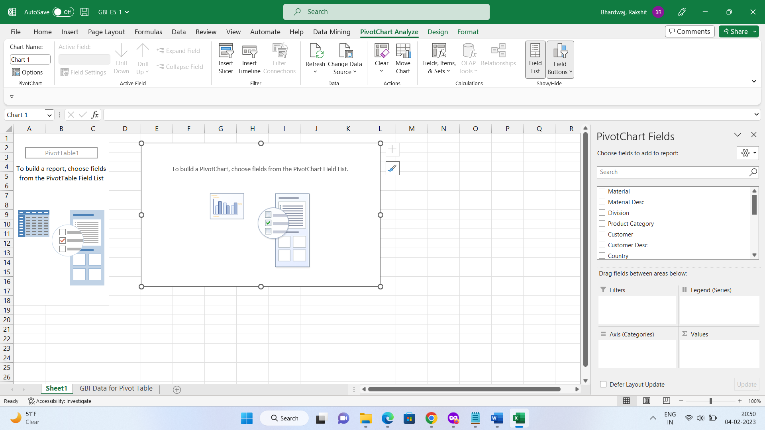

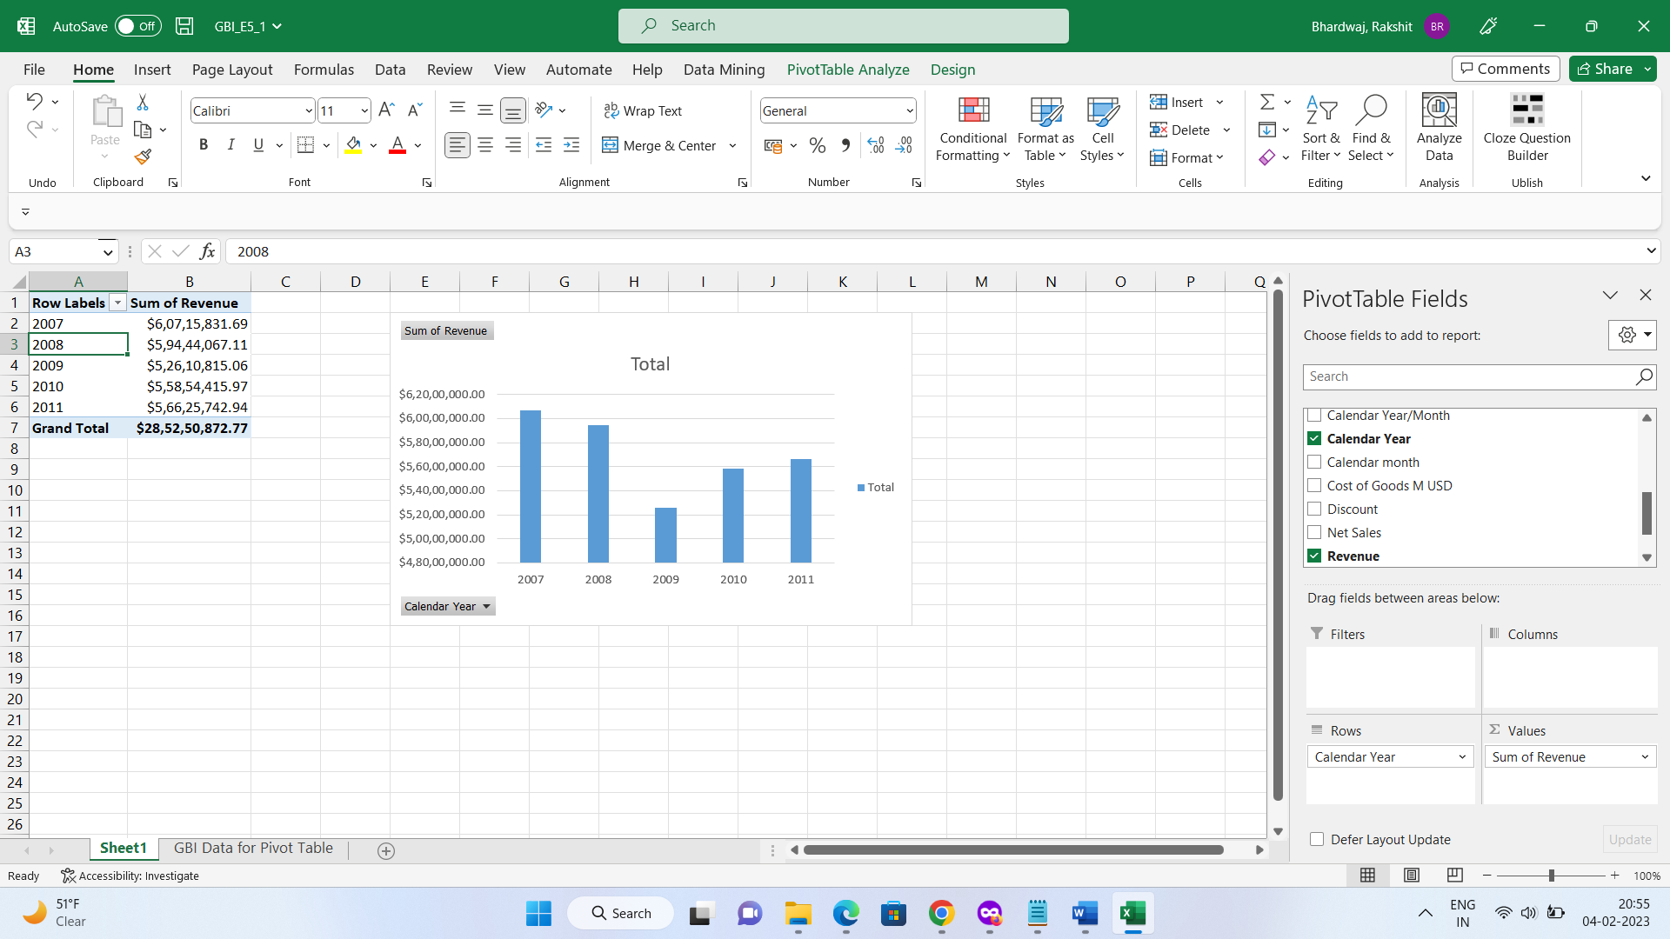

**Q1**

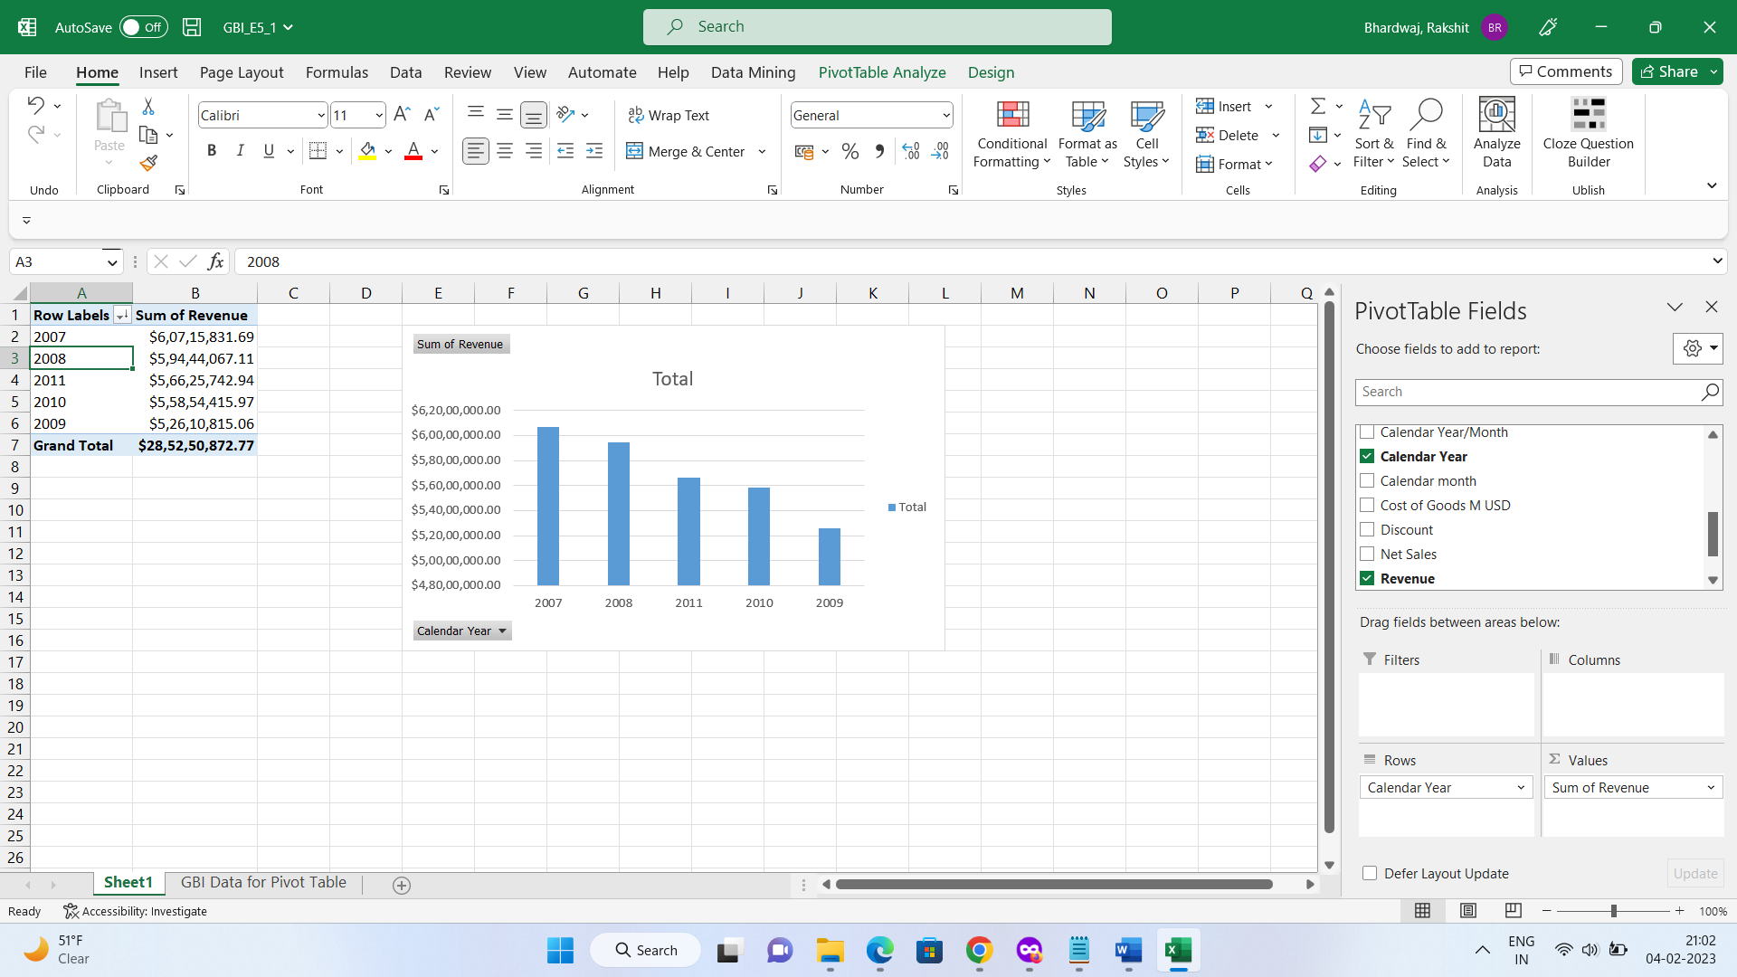

**Q2. and Q3.**

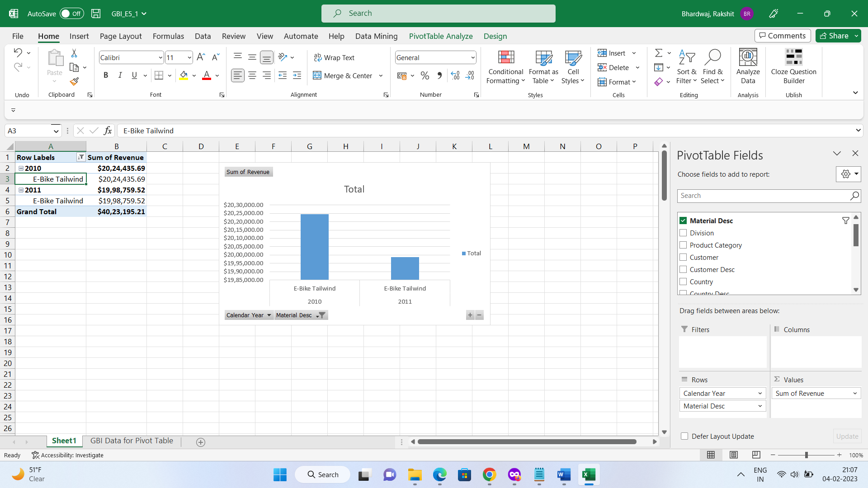

**Q4**

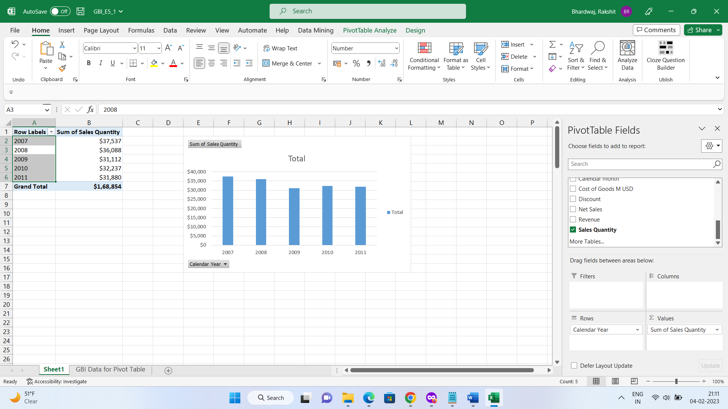

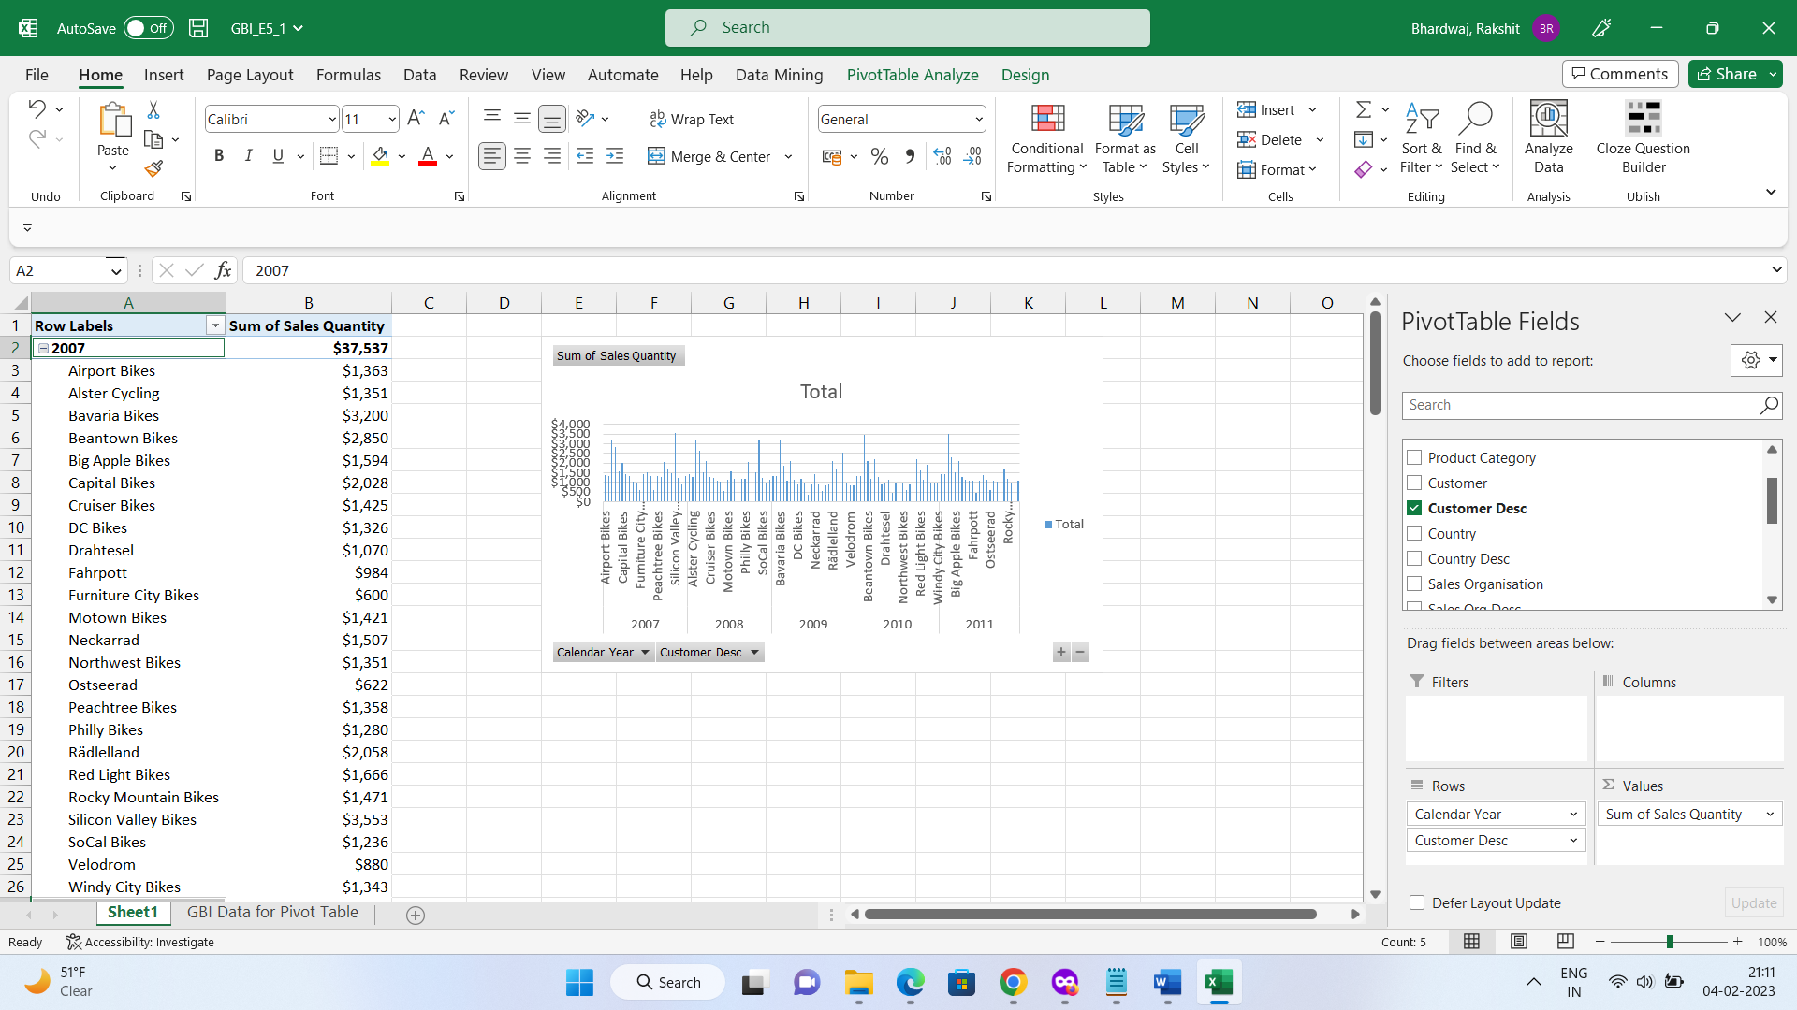

**Q5**

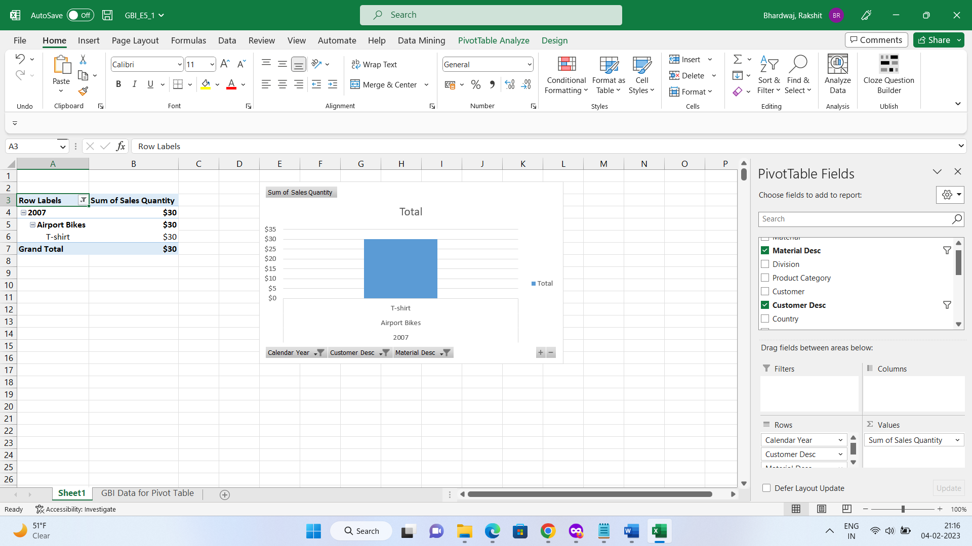

**Q6**

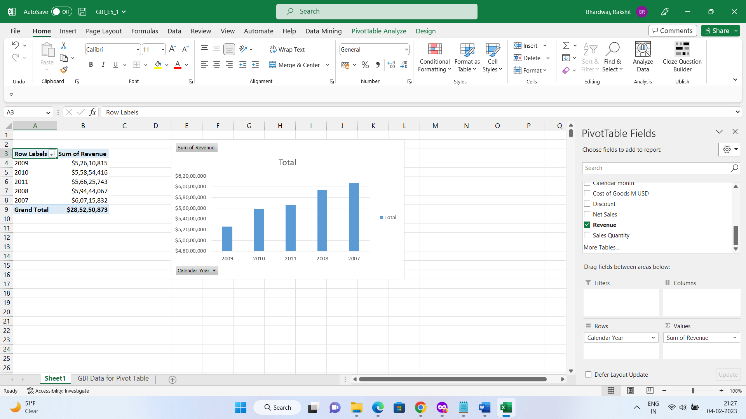

**Q7 and Q8**

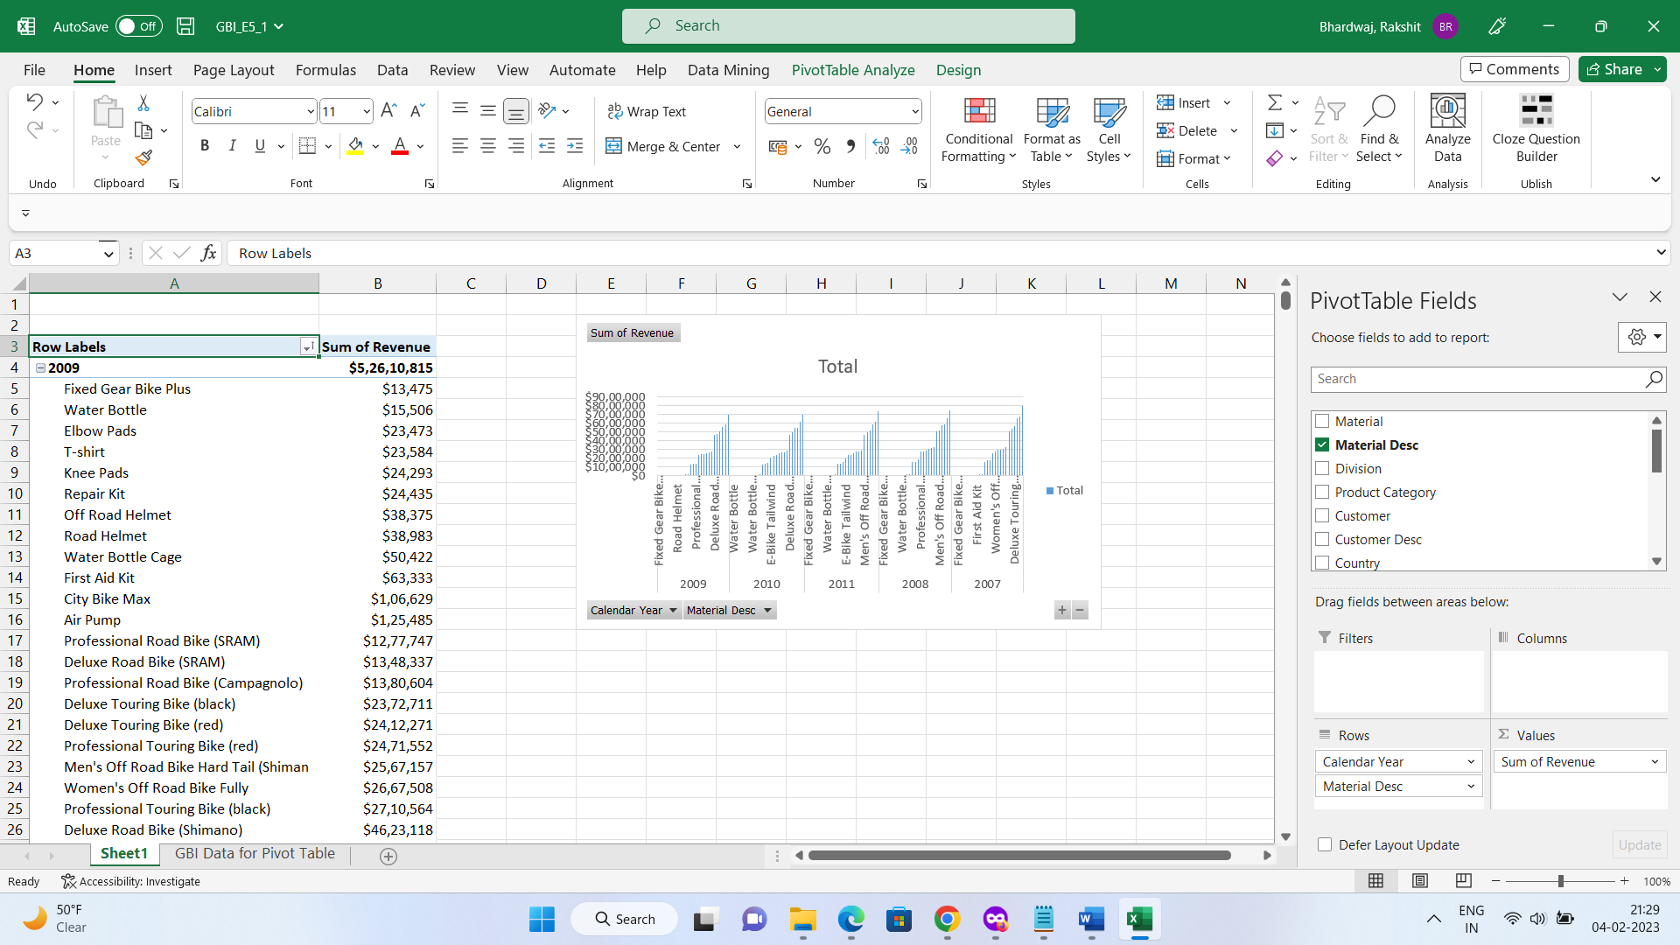

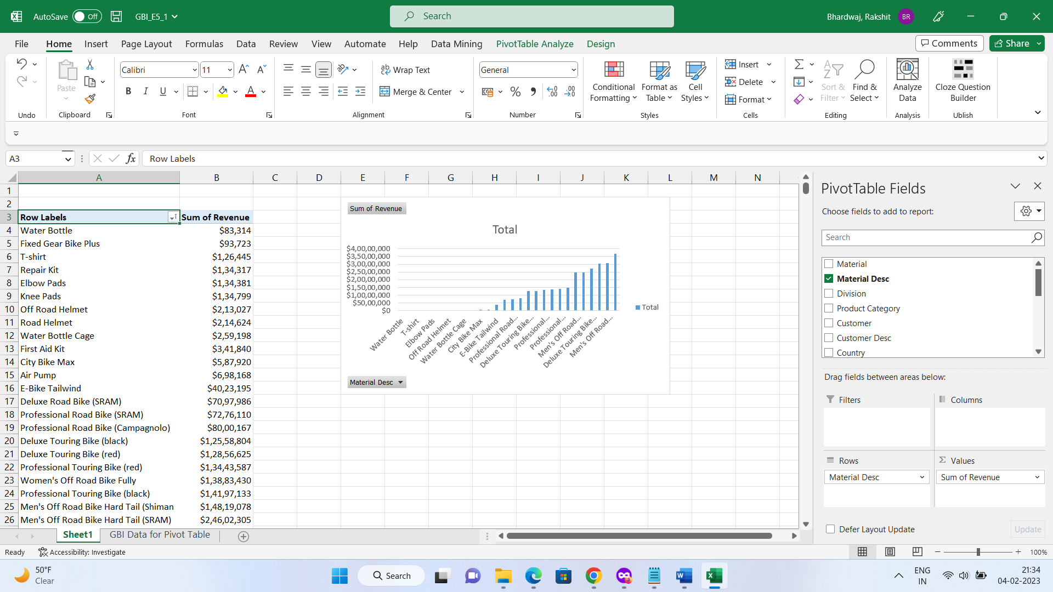

**Q9, Q10, Q11**

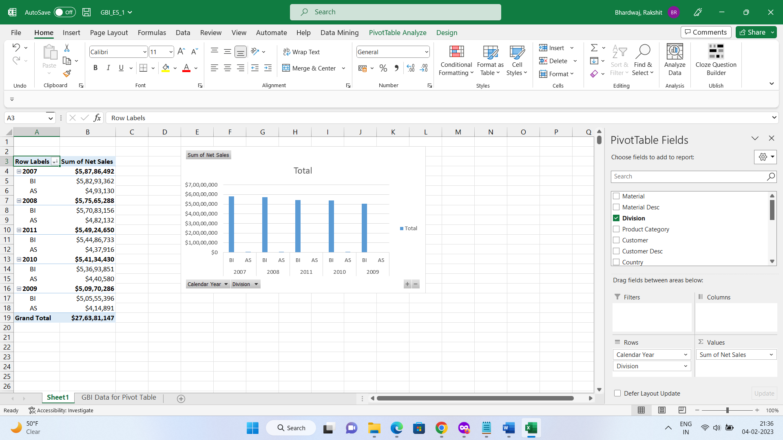

**Q12**

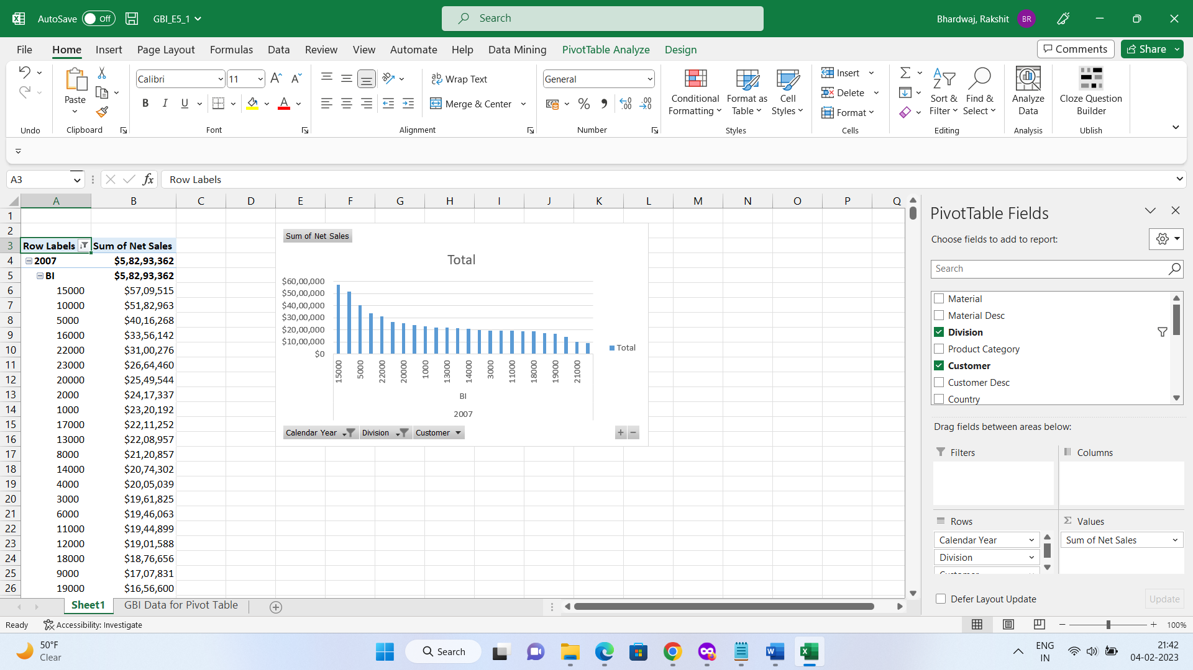

**Q13**

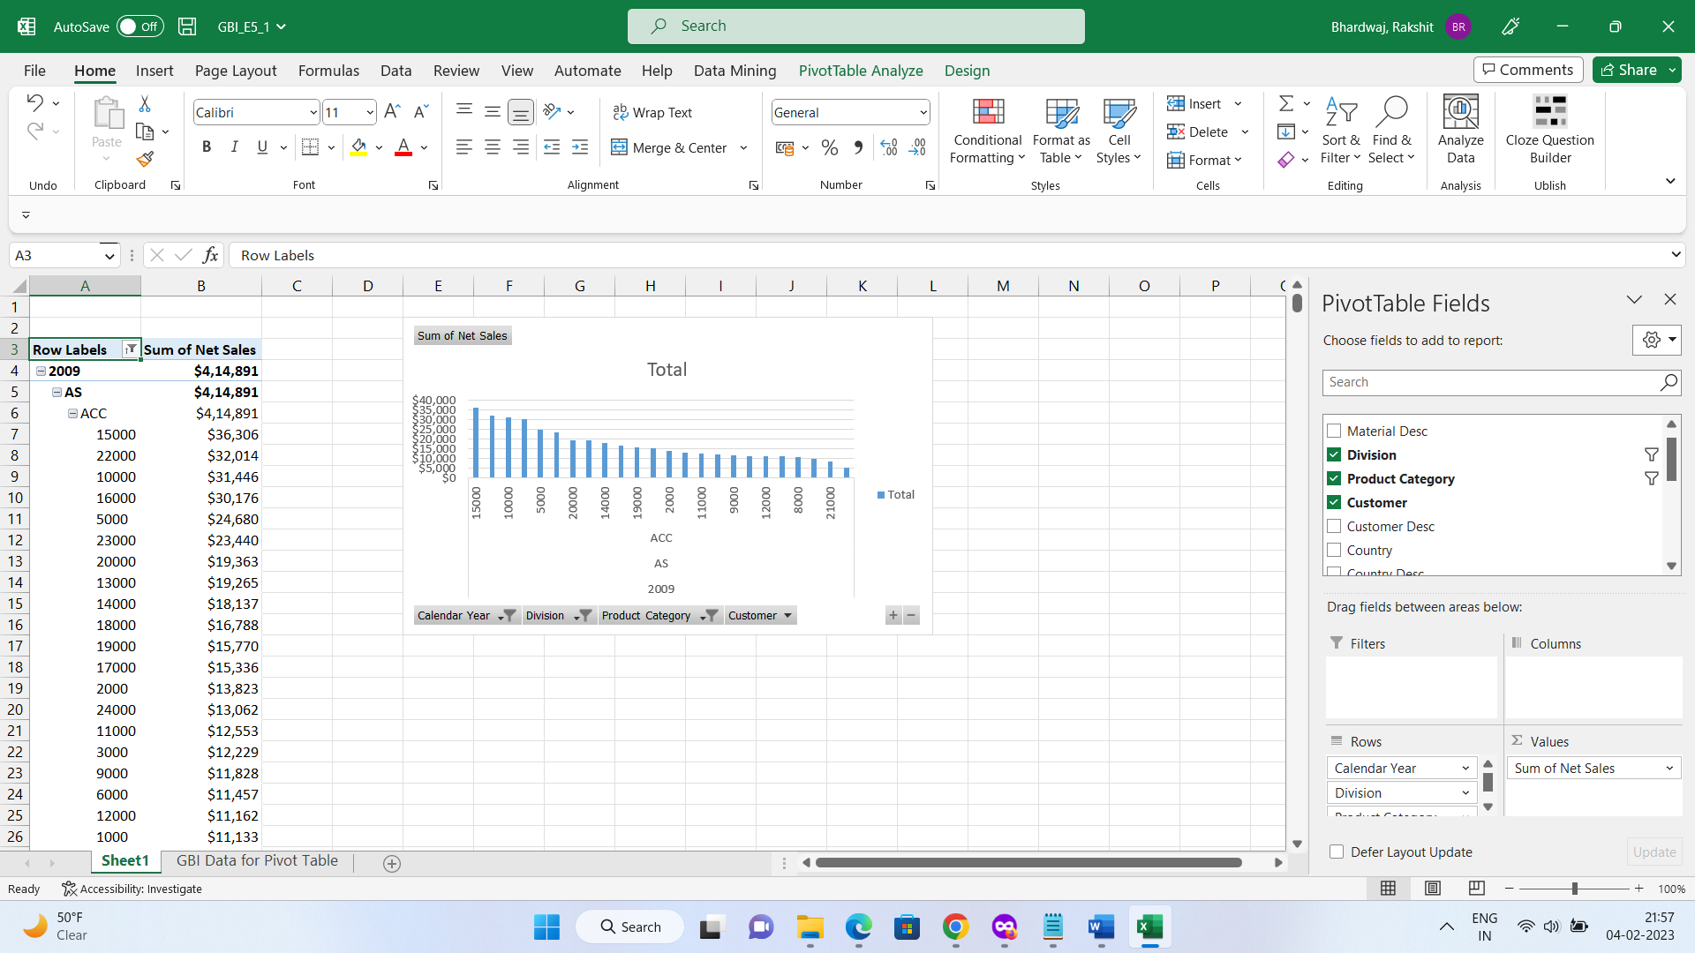

**Q14**

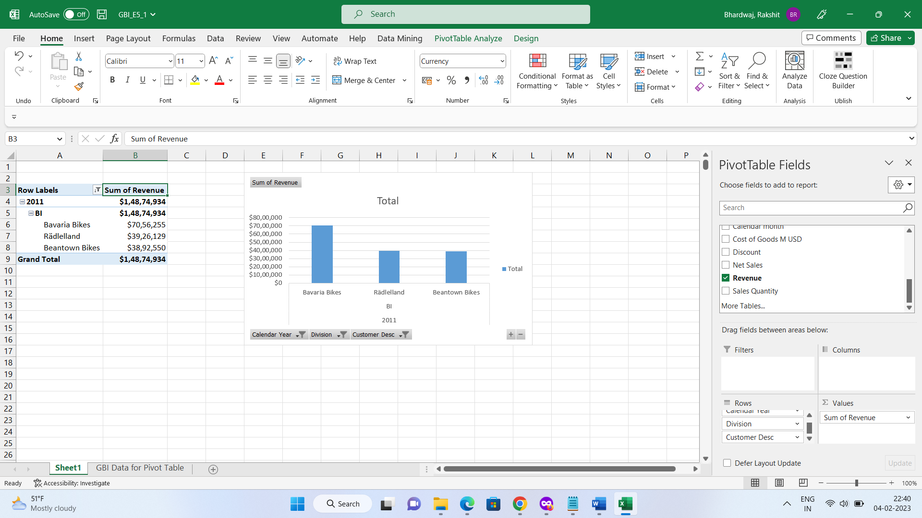

**Q15**

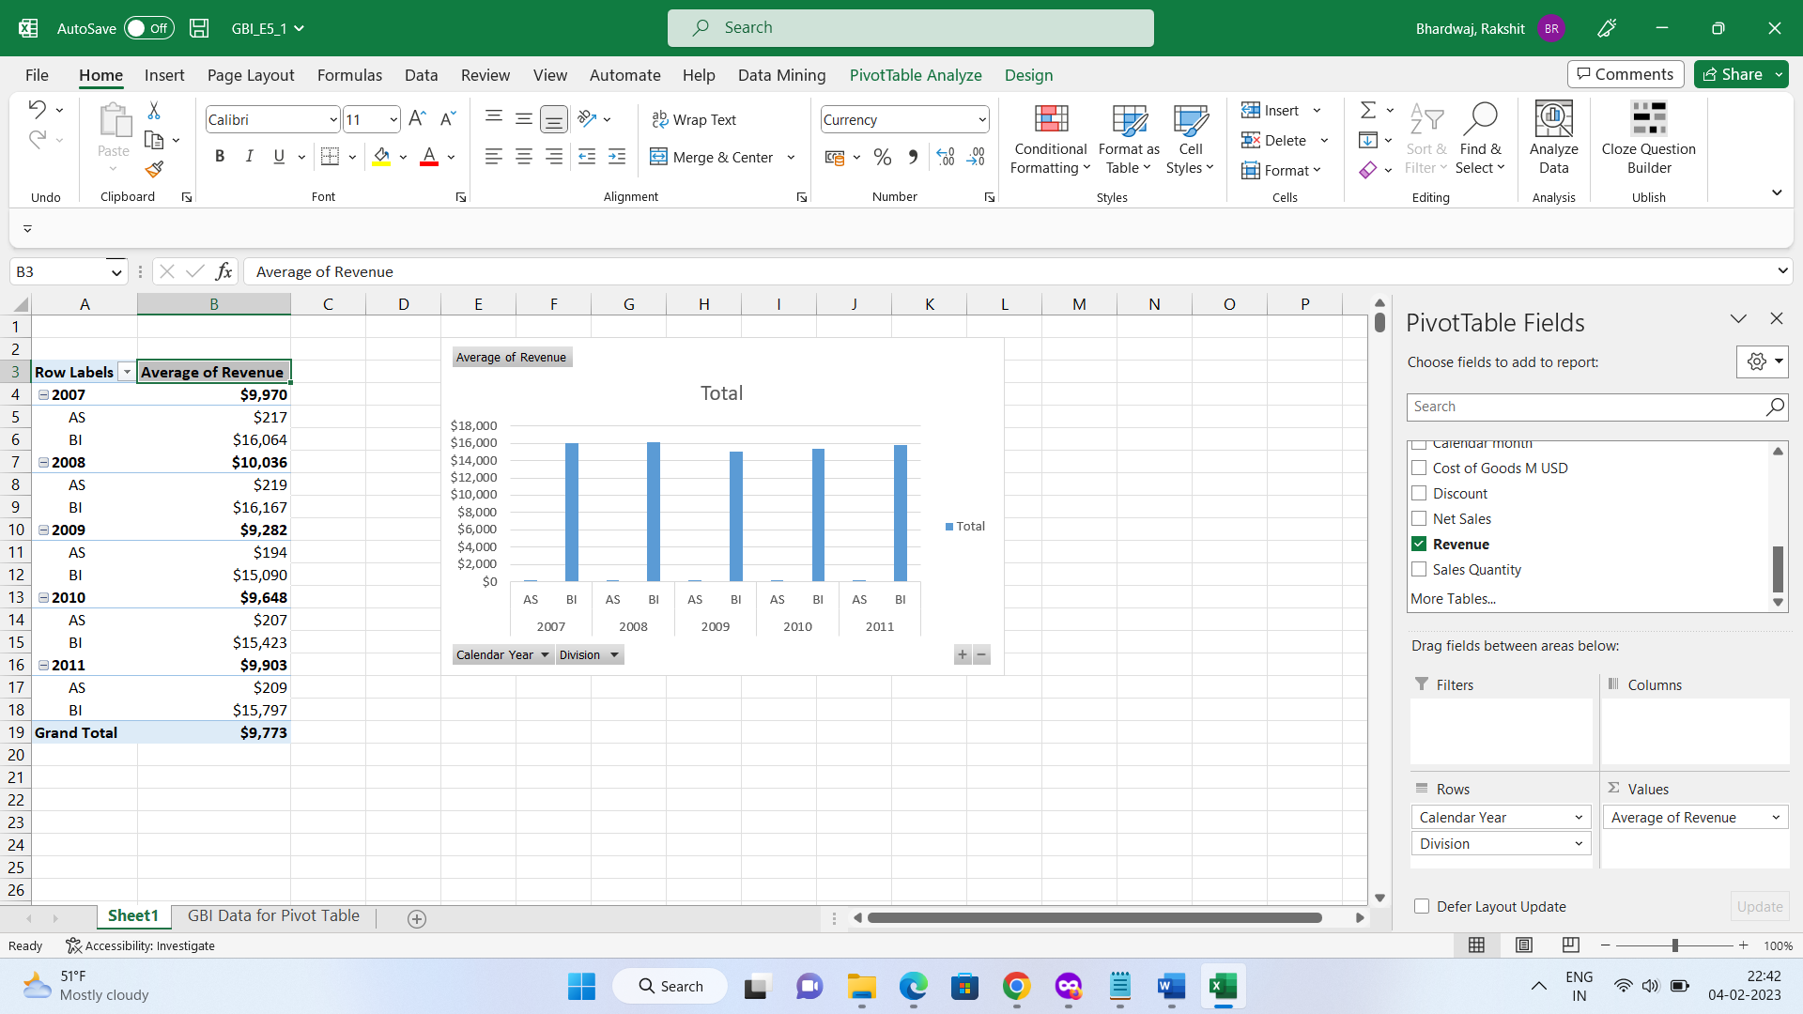

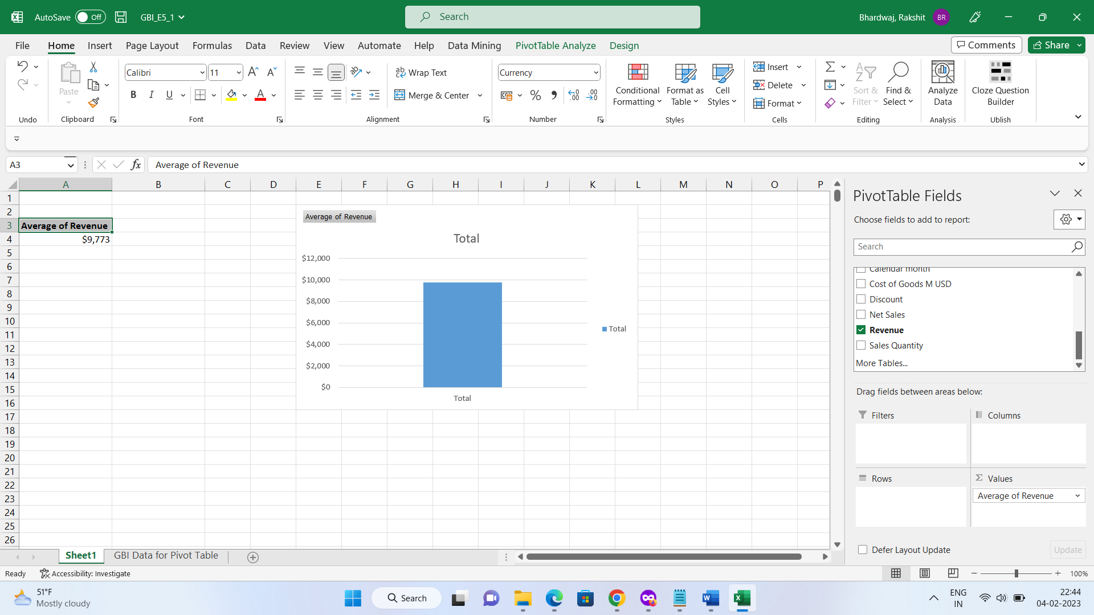

**Q16**

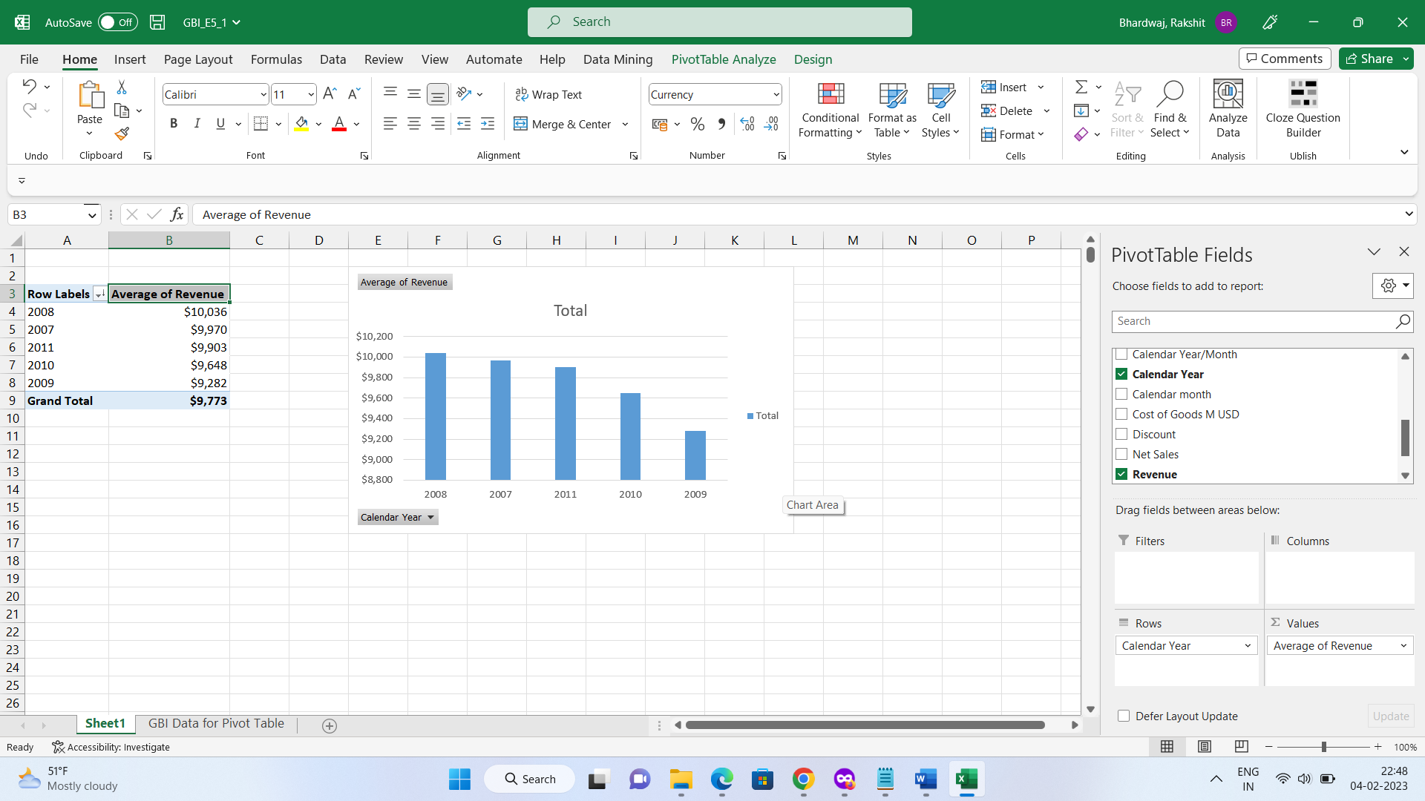

**Q17**

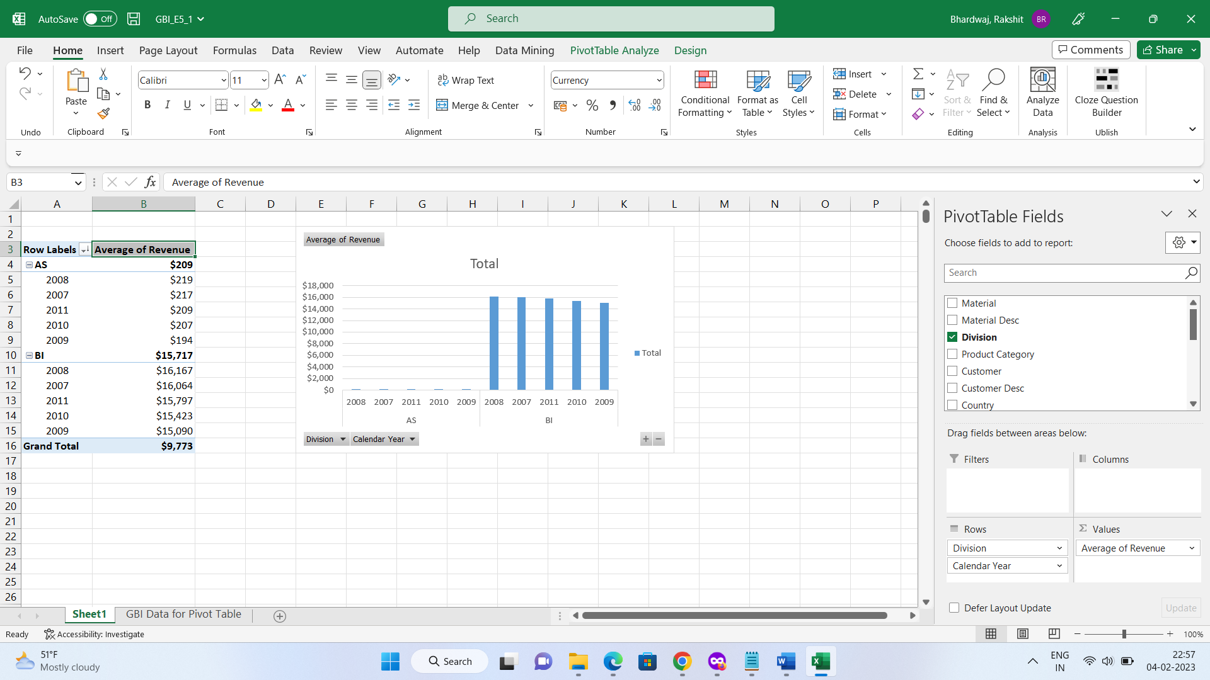

**Q18**

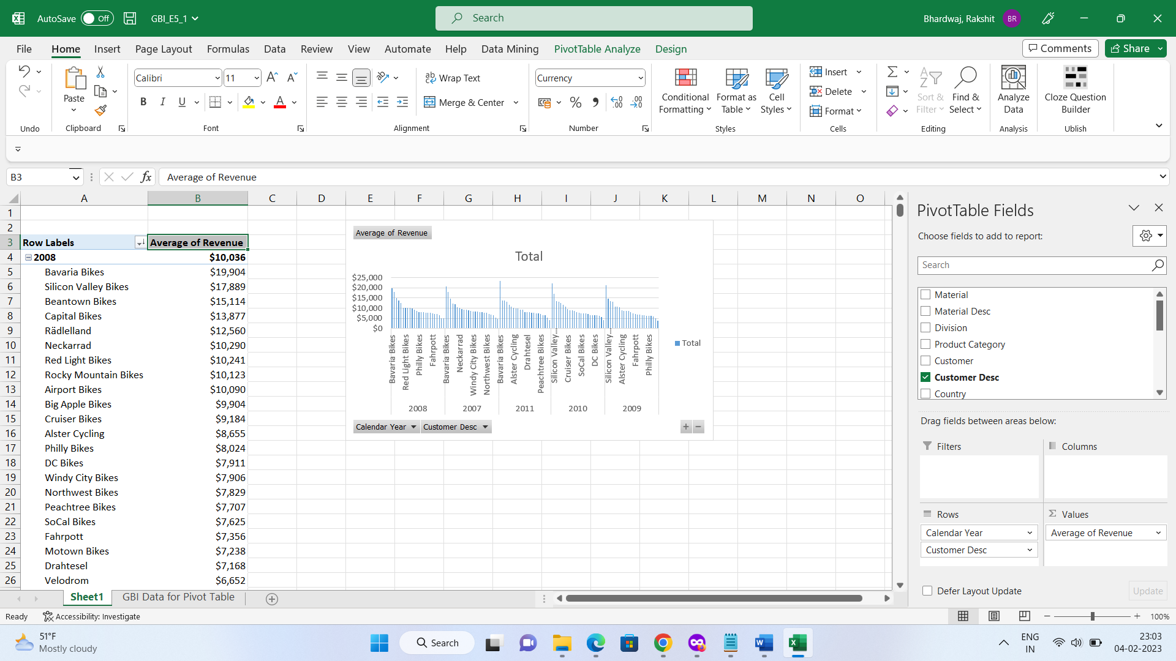

**Q19**

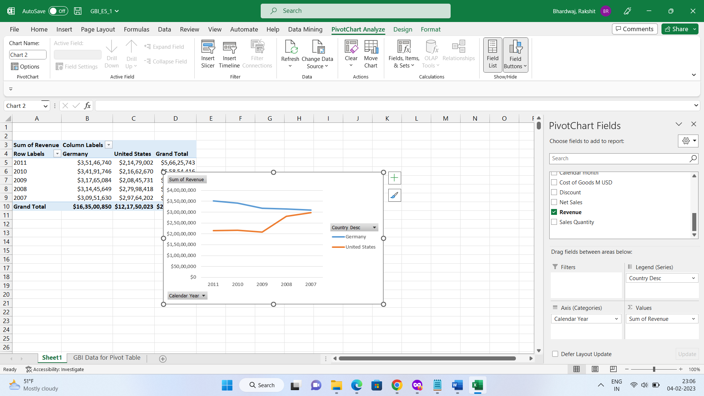

**Q20**

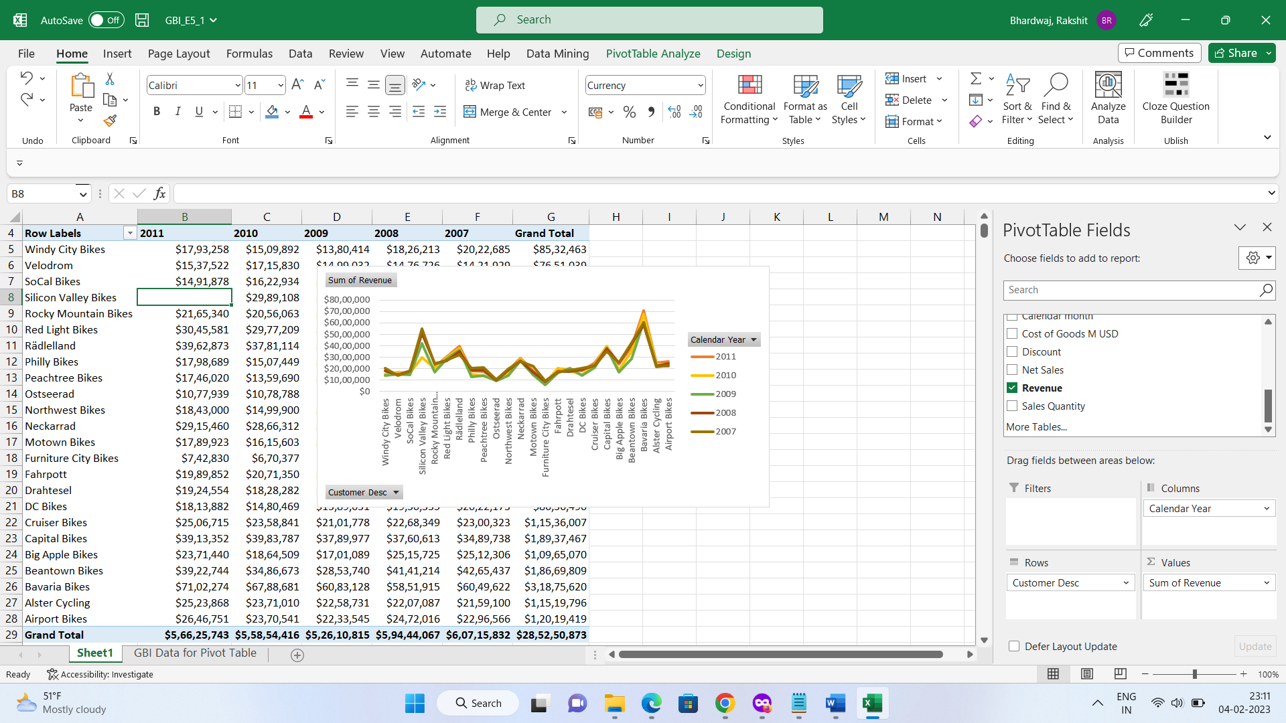

**Q21**

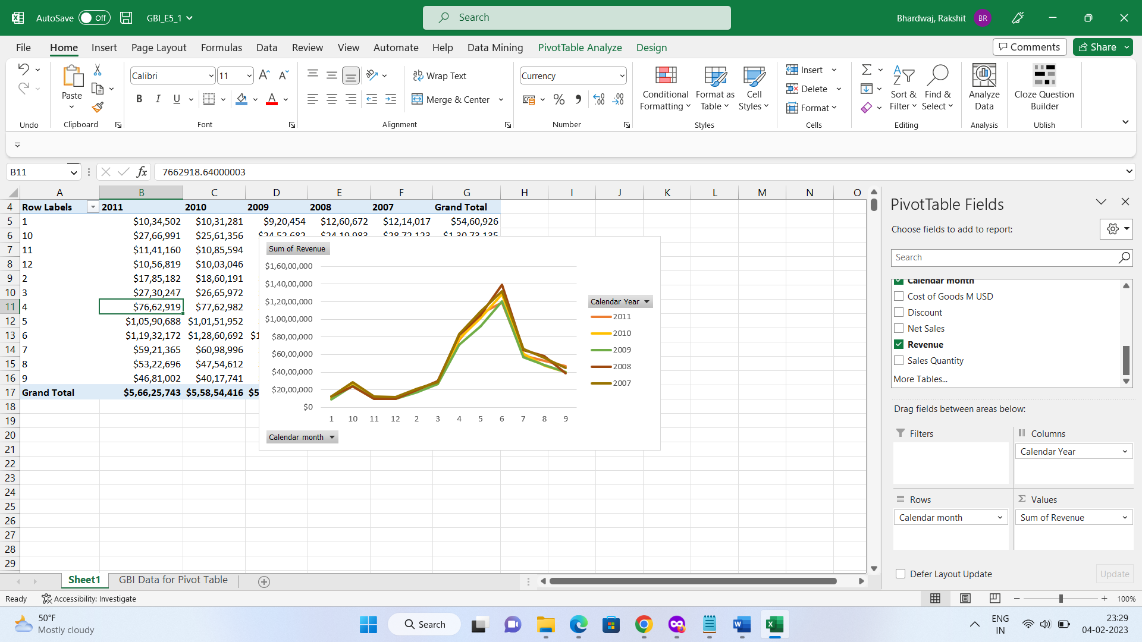

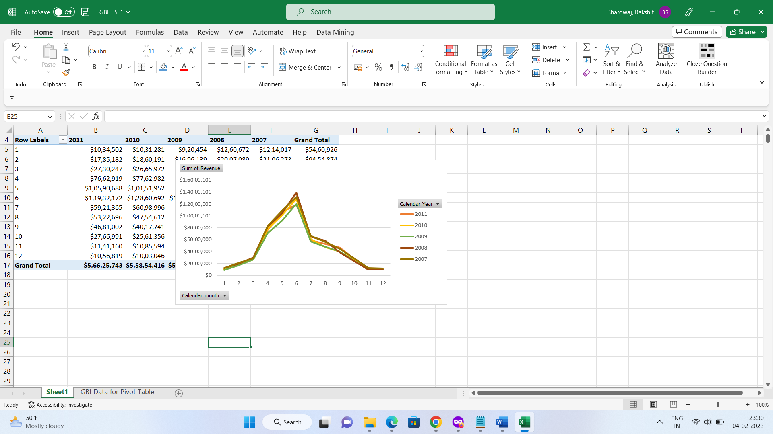

**Q22**

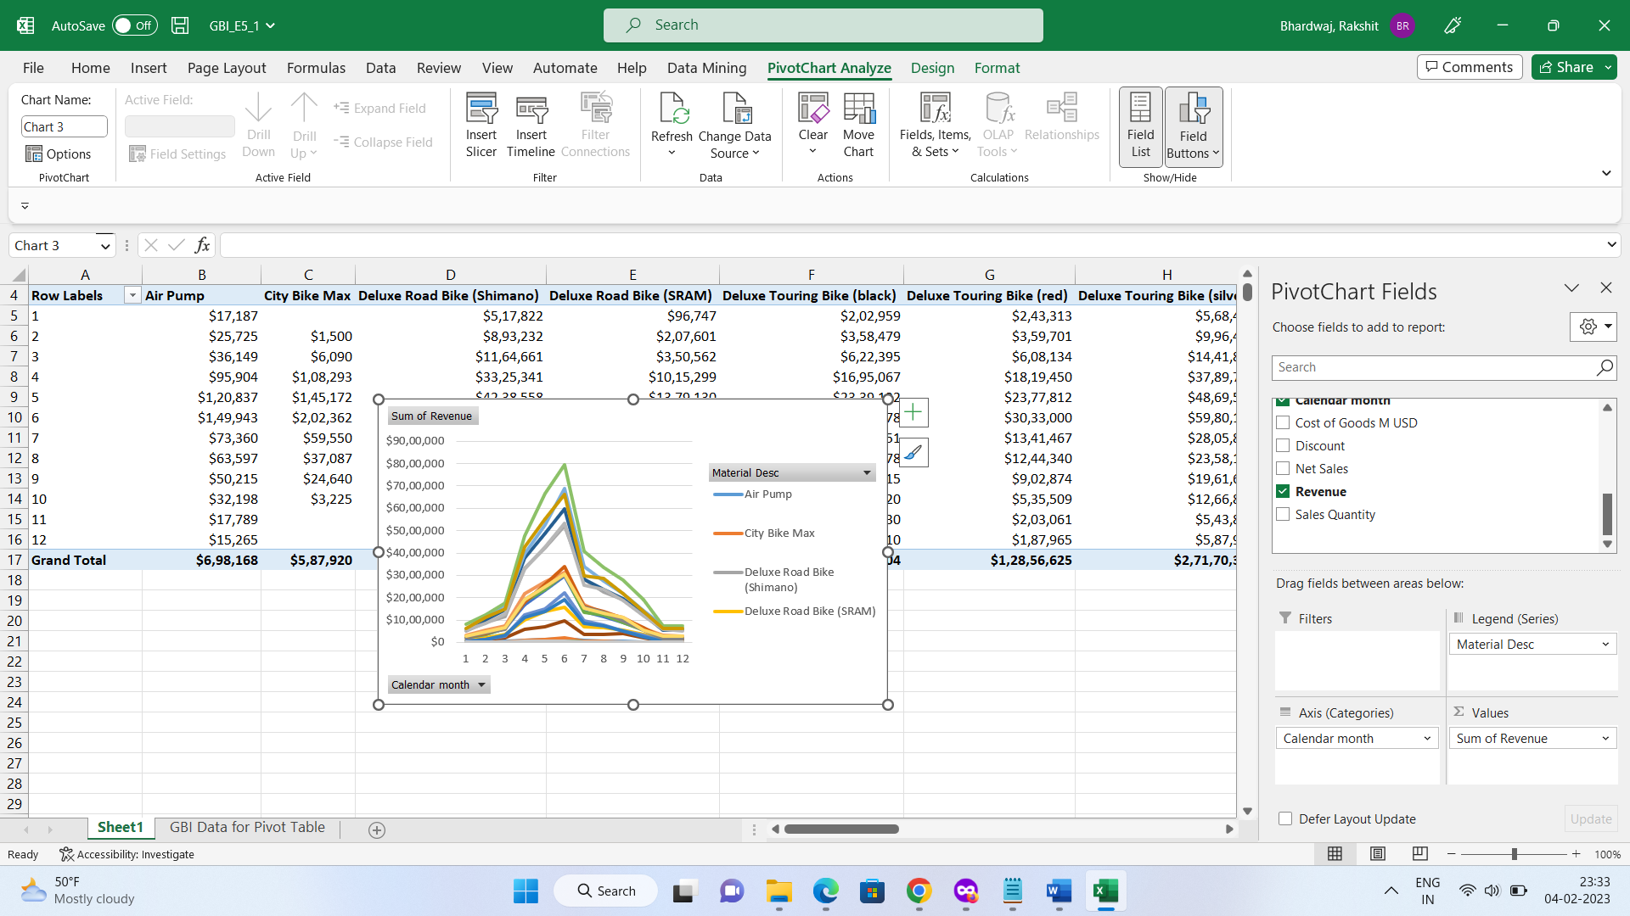

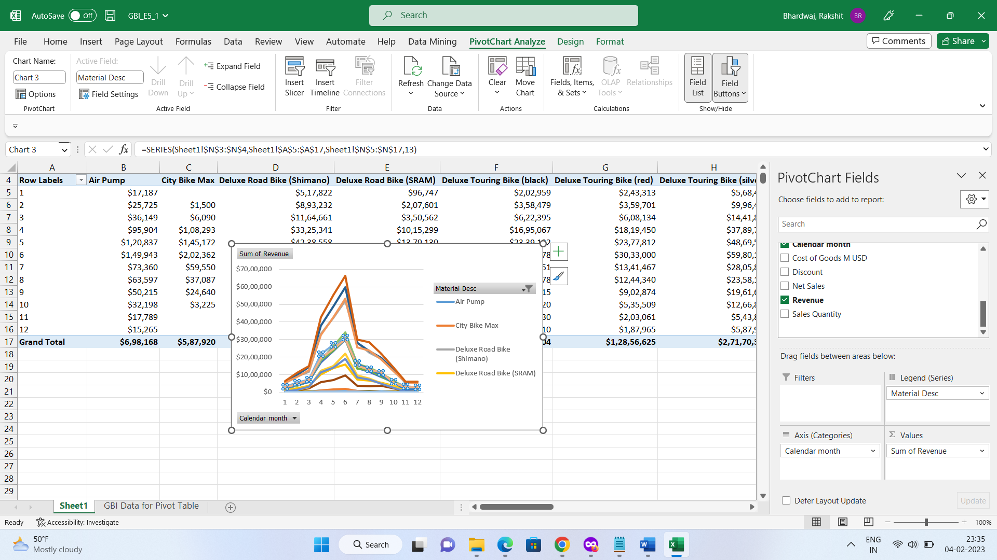

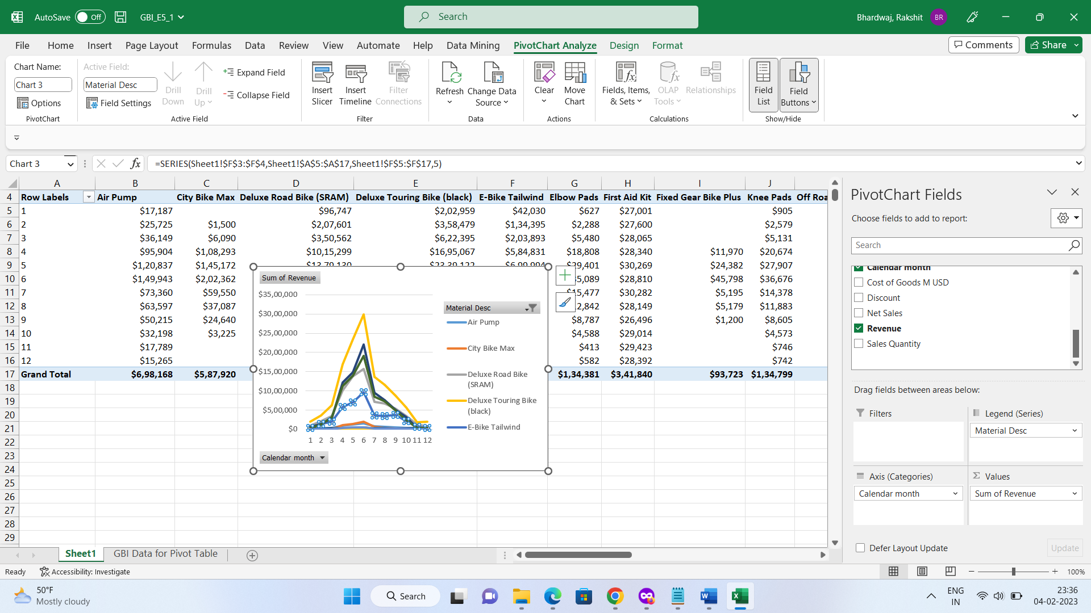

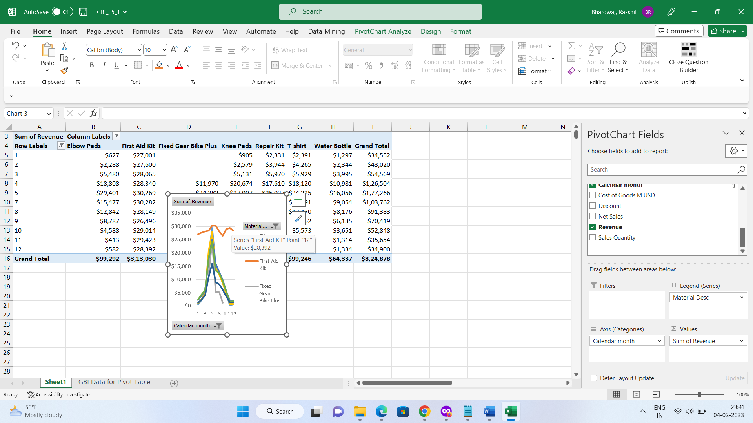

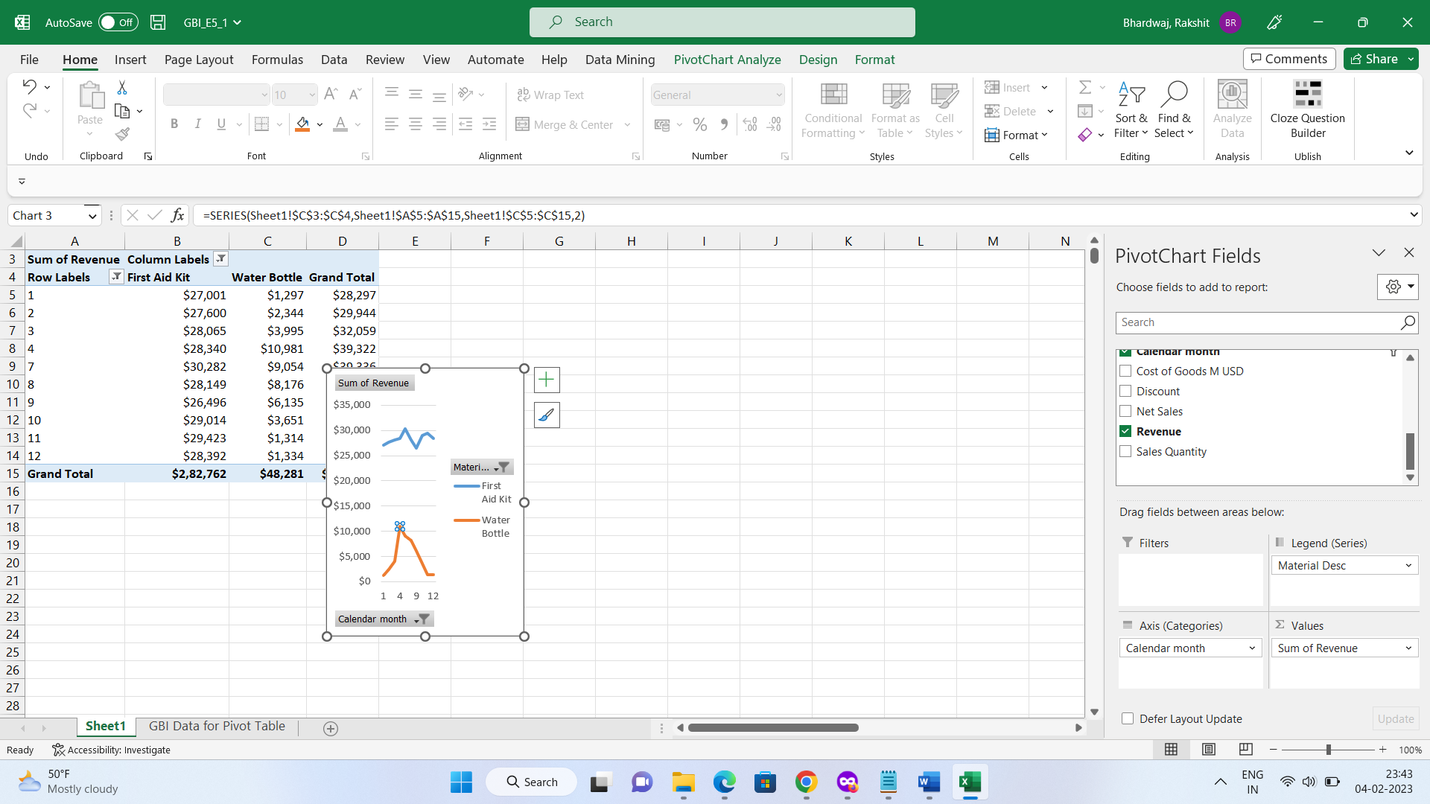

**Q23**

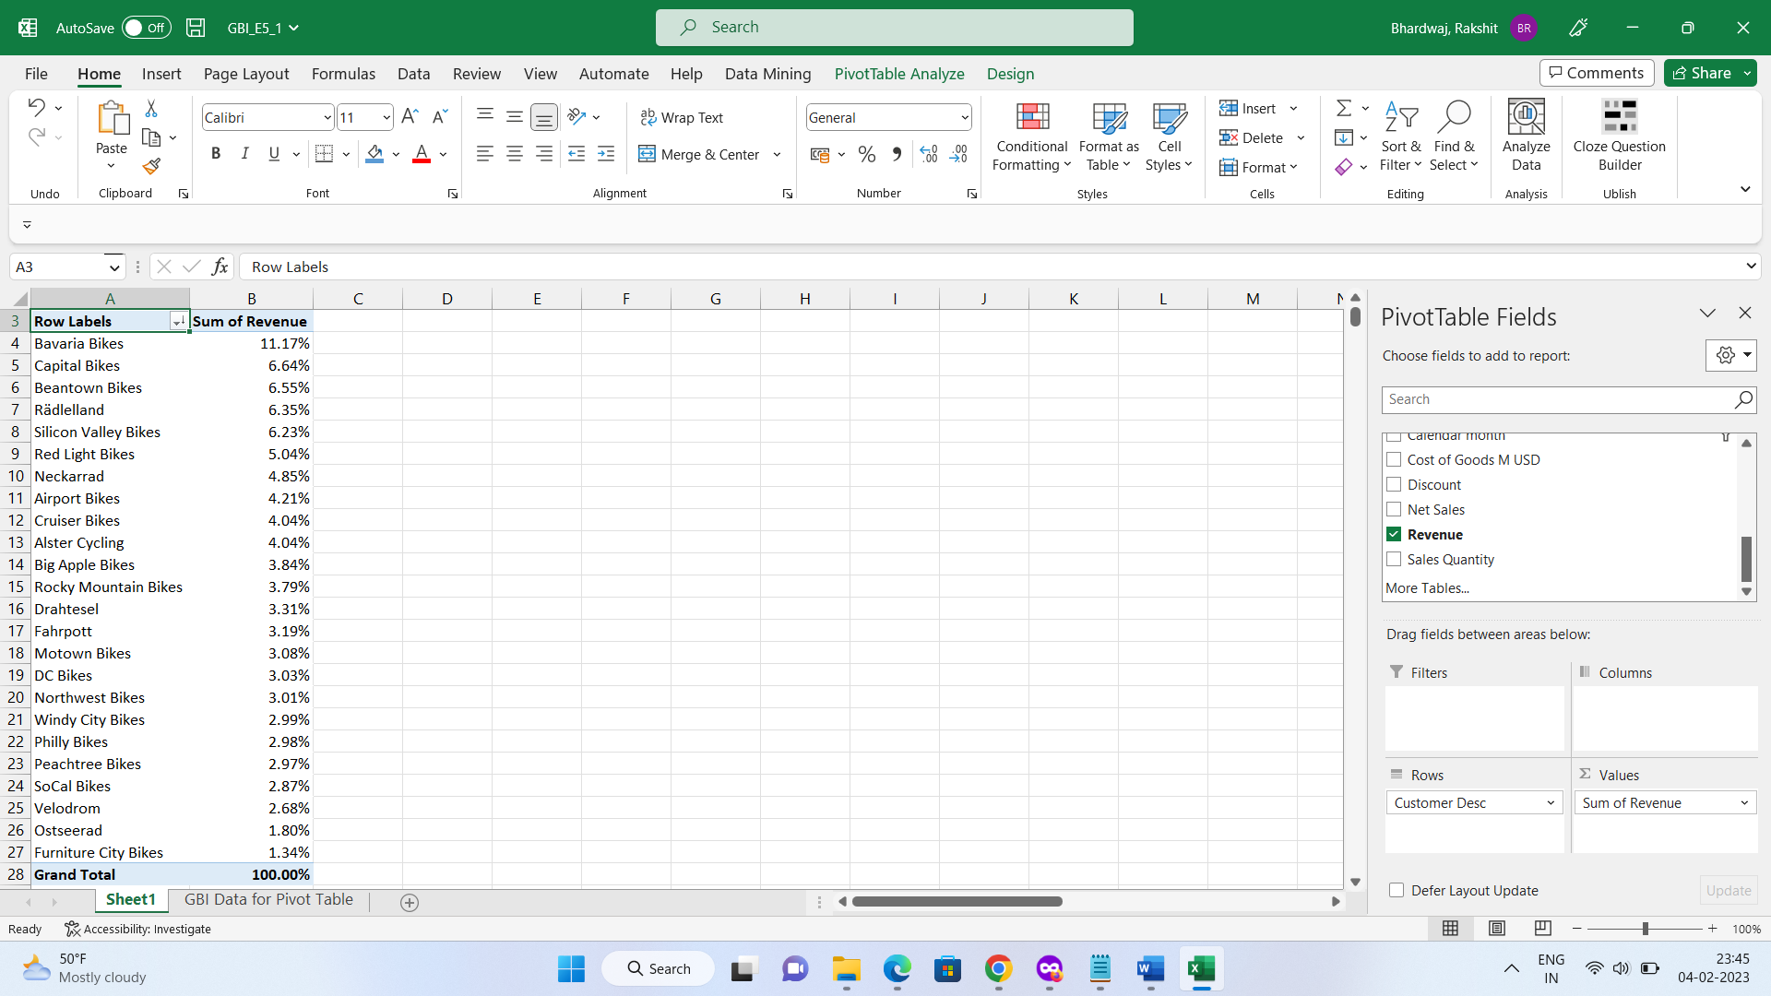

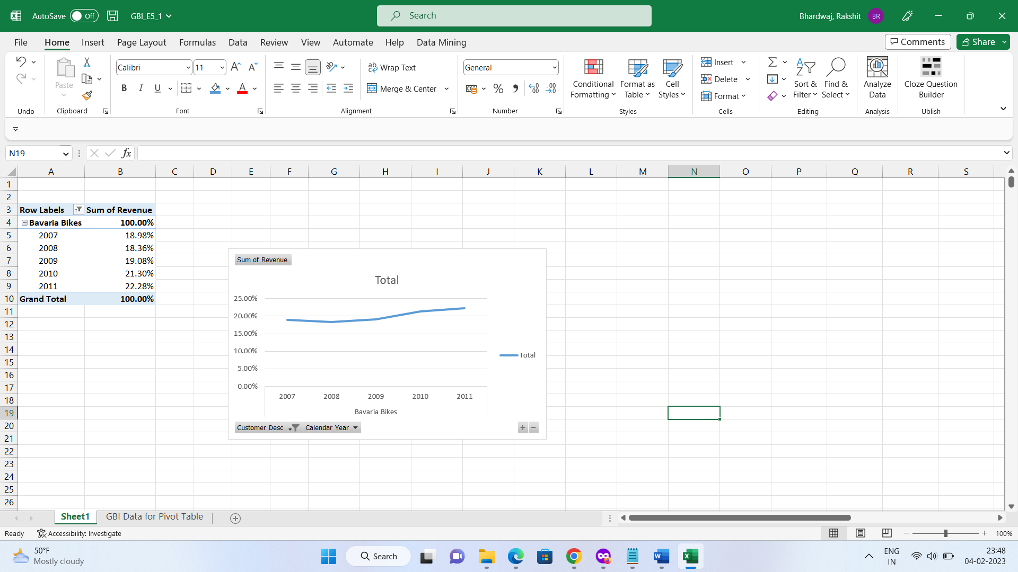

**Q24**

